**Unit test cases**

1. Script run without any input argument



1. Pass incorrect zip file details

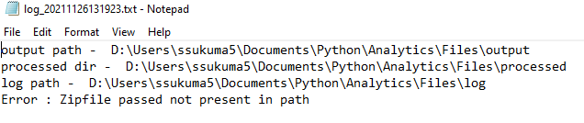

1. Zip file do not contain csv files

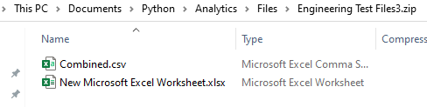

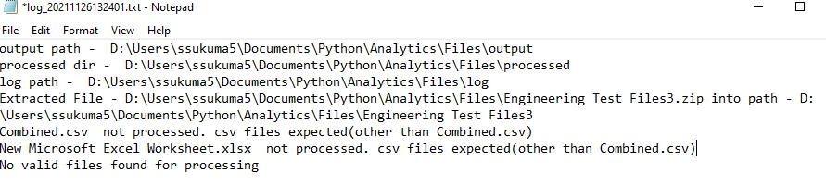

1. Run script passing the right zip file

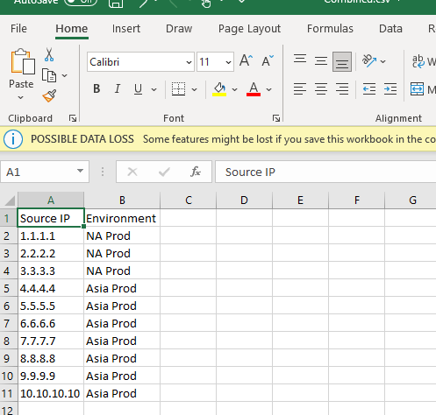

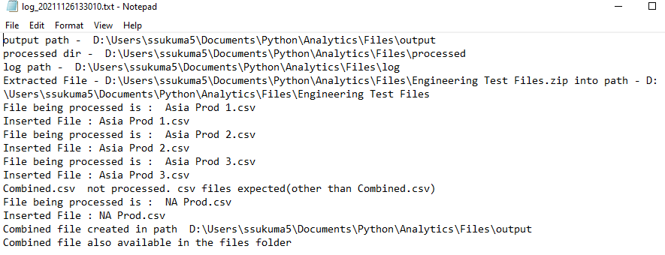

1. Run code adding NA Preview.csv with more data

